Digital Marketing: Its Importance and Types

Nowadays, there are numerous people who are exploring the world in a different way. The one basic platform that is enabling this is the Internet. The Internet has grown to such an extent that one can grab any damn thing at one’s fingertips. Earlier, the procedure followed for marketing is quite different from the modern age. This drastic change is due to the evolution of the digital world. The increase in traffic over the internet gave a positive impact on digital marketing to evolve. Let us get into detail in this article by discussing digital marketing, its importance, different types of marketing, and its applications.

# What is Digital Marketing (DM)?

It is a platform that is used to stay connected with customers via phone, laptop, or other electronic means such that any company can increase its marketing growth. In short words, marketing is not the place and time where a product is sold at its best. Basically, every company uses a marketing strategy to reach customers to the utmost level during a product launch. For instance, to grow the sales to the maximum level in very little time the process followed is known as Digital Marketing or Online Marketing. It helps not only to grow business but also helps customers satisfying their needs easily.



## Why is Digital Marketing Important?

The following two scenarios explain in detail why it is important:

* There are two types of marketing one is online and the other is Offline. The key difference between Offline and Online is an investment. Offline requires a huge amount of money to advertise a product whereas Online is a digital platform that does not require much investment. Whatever the approach is, the ultimate goal is to reach customers with less investment and indulge in profits.
* Earlier before the invention of the smartphone, people have indulged in activities like watching TV, shopping offline, listening to news via the radio, etc. But after the rapid increase in usage of the smartphone, everything changed. Even one can access their bank accounts, sell or buy products, online classes, and pay a vendor digitally via phone. As people got involved digitally, the scope of digital marketing has created a unique mark in today’s market. This made DM the best practice to proceed in doing business online.

## Different Types of Digital Marketing

The following are the four main different types of DM:

* Blogging
* Content Marketing
* Search Engine Optimization (SEO)
* Search Engine Marketing (SEM)

### Blogging

A blog is a place where one can find information relating to a different niche. It is updated usually which is the main difference between a website and a blog since the content on a website is mostly static. A blogger is a person who frequently posts relevant information on the blog.



Two important factors to be considered:

* The most important factor that should be considered while posting any content is the Keyword. Keywords play a crucial role because of whatever the content posted should reach the readers. Reaching readers depend upon the keyword like it should match the searching keyword of the user. When searching keywords matches the content in our blog then our page will be listed out in the search results of search engines.
* The other important factor that should be considered is the traffic to the blog. Organic traffic should be brought to the respective blog to earn more money. It depends on certain other elements like checking plagiarism, presenting unique content, amount of time spent by the user on the blog, the information provided on the blog should stand out of the heavy competition. However, SEO is a tool through which we can receive organic traffic free of cost as discussed below.

### SEO

This tool helps in bringing organic traffic to the website. It is a broad topic that explains how one can bring visitors to their respective blogs or websites.

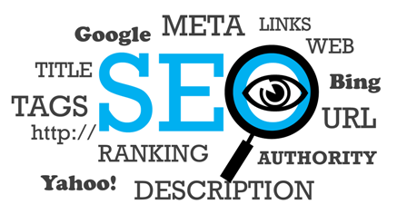

The two SEO types are White Hat and Black Hat. The first one says that google one will leave Google to analyze their blog on its own independent of the efforts to get it ranked whereas the former states that one compels google to rank their blog so that it gets displayed in the top search results page.

There are many other techniques that are followed in order to get ranked by Google. On-Page SEO and Off-Page SEO.

#### **On-Page:** This helps in following certain guidelines like keyword usage in meta title, meta description, and keyword description. Whenever the user searches using certain keywords, it should match the keyword in our blog. To ensure this, we should follow On-Page guidelines.

#### **Off-Page:** This helps in following certain guidelines like maintaining the page speed, fixing any errors or bugs on the page, each page should be separately titled with different category names, maintain privacy settings so that search bots of Google analyzes and starts ranking, file size, file name, file format, backlinks, interlinking, image size, ALT attribute, Image URL, text surrounding the image.

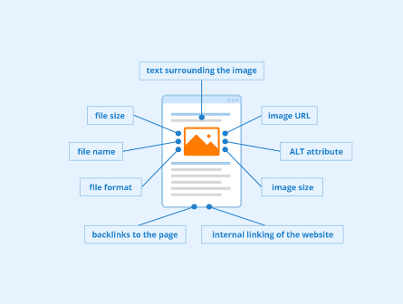

### SEM

Basically, it is a method that uses paid advertisements to appear on the search pages to grow the business. This mainly focuses on the audience through advertisements who search for anything on search engines like Google, Yahoo, Bing, etc. One can gain traffic through this source either by selling or buying ads. The key importance of SEM is that we can engage with the customer, promote the product, optimize, and even measure the analytics such that we can analyze and improve our strategy moving forward. We can advertise on Youtube, Facebook, Linkedin, and Twitter using Social Media Marketing.

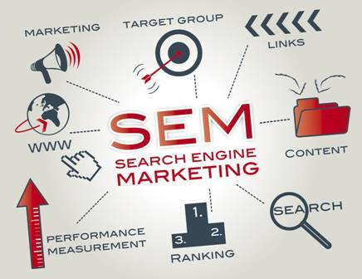

The main difference between SEM and SEO is, google earns money by displaying ads on search engines for SEM whereas SEO google provides a platform to earn money by showcasing our most relevant information to the users depending upon the keyword search.

### Content Marketing

This strategy is used to provide value first and can expect results later. Providing high-quality content will however be valued more. We can target the audience through the rich content that will be useful for the users such that we can drag them to our blog for any information they need. After adding value through content, earning can be expected from google due to the increase in traffic via advertisement posting on our blog. Even we market our courses through the blog and make money. The user always expects a new article or information from us. In order not to lose traffic, consistency and reliability should be maintained every time. Let us take the example of Youtube where users expect to watch our content via notifications if they subscribe. To meet the user’s expectation, value addition to the topic and consistency would deliver the utmost results.

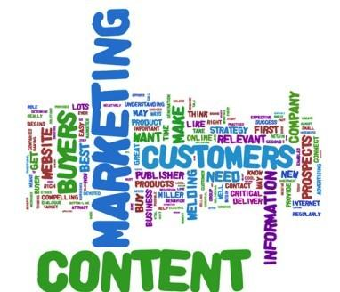

Thus, in this article, we have discussed the introduction of DM. It is nothing but a strategy of marketing that uses a digital platform to promote or grow business rather than traditional marketing followed earlier. In addition, we also discussed its importance, types of DM, and several other opportunities involved in making money digitally. Though this article only discusses the main concepts of DM, a full structure article is still available on the next page.